SMA-REACT: An open-source toolkit for shape memory alloy data visualization and constitutive model calibration

Patrick Walgren, Jacob Mingear, Darren Hartl

# Abstract

Post-processing shape memory alloy (SMA) characterization data and calibrating an appropriate constitutive model are vital but time-consuming tasks in the development process of a new SMA technology. Such tasks can be a daunting endeavor for prospective SMA users as the multiple data streams, filtering techniques, and constitutive model formulation should be understood. This prerequisite knowledge creates a barrier to entry, and potentially restricts the adoption of SMAs into new fields. We present a tool to post-process experimental SMA data, generate publication-quality images, and calibrate the Lagoudas constitutive model in an automated fashion. The Shape Memory Alloy Rendering of Experimental Analysis and Calibration Tool (SMA-REACT) is GUI-based and open-source, allowing for widespread adoption and modification. In this work, we describe SMA-REACT and calibrate a sample dataset to the Lagoudas one-dimensional constitutive model, providing an example workflow that can be easily replicated with user data. Our tool offers experimentalists, mechanicians, and designers a low-barrier-to-entry solution for post-processing and model calibration and helps speed the process between characterization and system integration.

# Introduction

Shape memory alloys (SMAs) continue to be sought as an engineering solution for applications requiring high recoverable strains and solid-state actuators [1]. While SMAs are critical to the modern biomedical and aerospace industries their complex material behavior and inherent thermomechanical coupling limits more widespread use [2], [3].

A notional process for developing a shape memory alloy engineering solution could be described with six stages, depicted in Figure 1. Step 1 requires identifying the system requirements which entails discerning a suitable range of material requirements (i.e., stiffness, actuation strain, transformation temperatures). These material requirements directly drive step 2: choosing the precise SMA composition. The arduous journey of turning a concept into an engineering component involves many iterations between steps 3-5, i.e., processing, characterization, and constitutive model calibration. Processing, such as rolling temperatures or additive manufacturing print parameters, influences material properties [4]. Characterization enables the simultaneous assessment of the new processing techniques and responses to loading conditions (e.g., tension, compression, or torsion). Rigorous engineers may seek to validate the behavior of a new material within the original system requirements. This validation requires an appropriate constitutive model calibration (i.e., a material model that accurately predicts the thermomechanical characterization data). With a calibrated constitutive model (such as the Lagoudas [5] or Brinson [6] models), engineers can design the system to exploit the unique nonlinearities of SMAs. Once the chosen material satisfies the original requirements, the SMA device can then be integrated into the system.

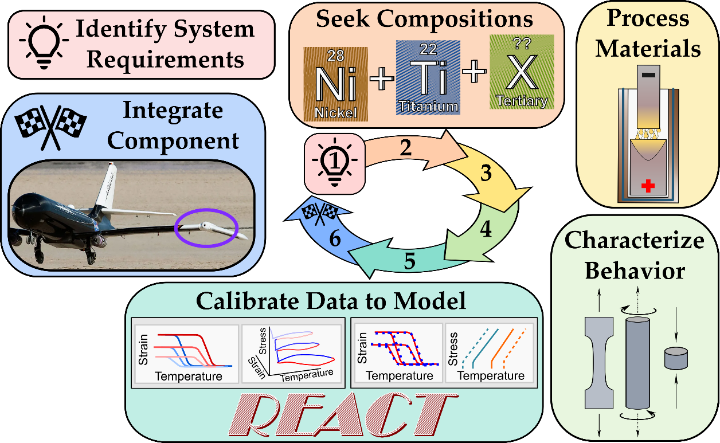

Figure : SMA device development may involve many discrete steps. This work provides an easy constitutive model calibration tool, the Shape Memory Alloy Rendering of Experimental Analysis and Calibration Tool (REACT), to enable SMA component design.

Such design processes involve many disciplines and can be a daunting endeavor for small teams or new adopters of SMA technology. The SMA development process detailed in Figure 1 requires significant time and effort, but the community has developed tools to expedite certain stages.

The composition-processing-property space for SMAs is becoming well understood, and many recently developed tools enable alloy discovery [7], [8], [9]. ASMADA, the Automatic Shape Memory Alloy Data Analyzer, identifies heating and cooling cycles from experimental data and extracts SMA material properties according to ASTM standard E097 [10], [11], [12]. The Shape Memory Materials Analysis and Research Tool (SM2ART), also known as SMAnalytics, provides an extensive open-source database of tested shape memory alloys and their standard properties [13], [14]. Many research groups have published user material models (i.e., UMATs) to interface with open-source and commercial finite element solvers [15], [16], [17], [18]. However, while many published methods detail SMA actuator calibration [19], [20], [21] and commercial software suites enable superelastic calibration [22], no open-source calibration tool for SMA actuation exists.

In this work, we detail a streamlined, GUI-based tool to help both material scientists and design engineers analyze their thermomechanical data and calibrate an appropriate SMA constitutive model. We deem this tool SMA-REACT: the Shape Memory Alloy Rendering of Experimental Analysis and Calibration Tool. The main functions of SMA-REACT are notionally depicted in Figure 2. Our tool provides an intuitive workflow that processes raw unfiltered shape memory alloy mechanical (tensile/compression), thermal (DSC), or thermomechanical (tensile/compression with environmental chamber) data to produce customizable figures. Additionally, SMA-REACT enables rapid model calibration by leveraging numerical optimization. The tool is written in python but requires no programming experience; it is available on GitHub ([github.com/maestrolab/SMA-REACT](https://github.com/maestrolab/SMA-REACT)) and distributed under the GNU General Public License [23]. Two modules accomplish the essential tasks of data processing and constitutive model calibration.

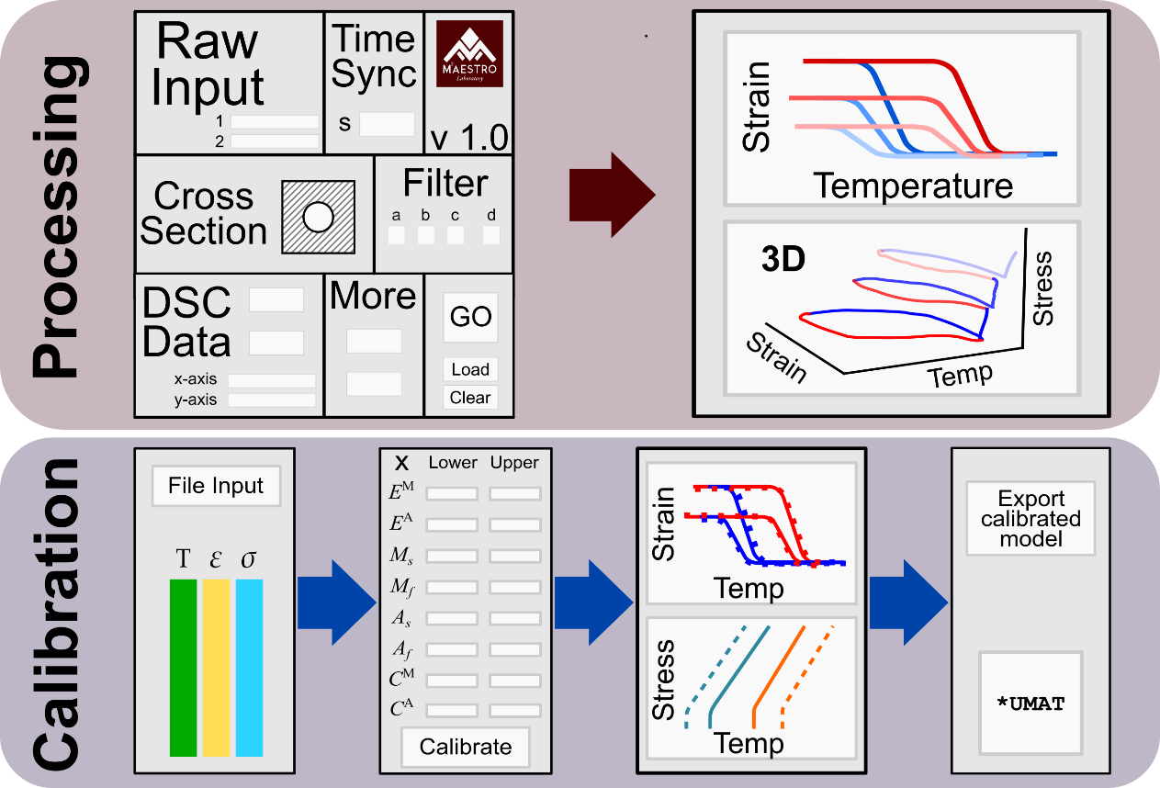

Figure : SMA-REACT allows the user to load their own data, specify known material parameters, and find an optimal calibration that best approximates experimental response.

# Method description

## Data processing module

Shape memory alloy characterization requires acquisition of stress, strain, and temperature histories. Sometimes these histories rely on different telemetries and must be synchronized into a single data file. The SMA-REACT processing module extracts data from multiple inputs such as a load frame and external thermocouples and automatically synchronizes them onto the same time series. With unfiltered force and displacement data, the tool can calculate strains and stresses based on various sample geometries and then apply filters to remove systematic errors within the dataset. The program then produces various figures to help visualize the complex shape memory alloy material behavior. Users can export this processed data to the next module of the tool, model calibration.

## Model calibration module

Constitutive model calibration (i.e., the process of finding the parameters that best reproduce experimental data for a chosen model) is a vital link between SMA behavior and intended system performance. For many applications, selecting a particular SMA component based on transformation temperature and maximum transformation strain is insufficient; the transformation temperatures and actuation strain in the *operating stress regime* must be well characterized and predictable.

Simple SMA constitutive models can be calibrated via closed-form analytical expressions [19], [20]. However, for more complex constitutive models more representative of SMA behavior, a nonlinear curve fitting or numerical optimization routine is commonly required. While many methods exist in literature, these approaches exist as purpose-built codes and are have limited applicability outside the authors’ specific application or research group [21], [24], [25], [26].

Given filtered and synchronized experimental data from the processing module, the SMA-REACT model calibration module finds the best fit of constitutive material parameters (martensitic elastic modulus, austenite start temperature, etc.) based on the Lagoudas one-dimensional constitutive model. The developed calibration routine leverages hybrid optimization to minimize error between model prediction and experimental data. Hybrid optimization comprises a global optimization to identify a starting point for a local gradient-based optimization. Our tool enables the user to customize the optimization routine as well as the bounds and free variables for the material parameters to be optimized. Outputs from the calibration routine include a set of material parameters to be used in future analyses (i.e., inputs for a user material model) and a thermodynamically consistent phase diagram.

Our tool leverages the genetic algorithm NSGA-II [27], [28] for the global optimization and then SLSQP implemented in SciPy [29] for the gradient-based optimization, although the tool is modular and can be modified to use other algorithms. While we focus on the one-dimensional Lagoudas model for SMA actuators herein, the developed framework can be expanded to consider other constitutive models and different loading modes (e.g., superelasticity or combined loading).

### The one-dimensional Lagoudas SMA constitutive model: A brief primer

The Lagoudas shape memory alloy constitutive model uses the Gibbs' free energy to derive a thermodynamically consistent relationship between stress and strain. In this section, we will omit a full model derivation (see Lagoudas et al. [5] for more information) , but rather highlight the seventeen unique but dependent material parameters that need calibrated and their effects on constitutive behavior. The Lagoudas one-dimensional constitutive model comprises four interdependent parameter groups, as shown in Table 1.

Table :The one-dimensional reduction of the Lagoudas SMA constitutive model requires calibration of seventeen unique but dependent parameters.

|  |  |  |
| --- | --- | --- |
| **Parameter** | **Mathematical Symbol** | **Units (SI)** |
| **Thermoelastic properties** |  |  |
| Elastic moduli |  | Pa |
| Thermal expansion coefficient |  | 1/K |
| **Transformation properties** |  |  |
| Transformation temperatures (at zero-stress) |  | K |
| Stress-influence coefficients |  | Pa/K |
| **Transformation strain properties** |  |  |
| Minimum transformation strain |  | m/m |
| Maximum transformation strain |  | m/m |
| Critical stress at which transformation strain manifests |  | Pa |
| Transformation strain rise time |  | 1/Pa |
| **Smooth hardening properties** |  |  |
| Smooth hardening coefficients |  | - |

1. **Thermoelastic properties** include the elastic moduli for each material phase ( and for austenite and martensite, respectively) and the thermal expansion coefficient . The thermal expansion coefficient is assumed to be constant with respect to material phase (i.e., , allowing for the use of convex cutting plane to solve for the material state [5], [30].
2. **Transformation properties** include zero-stress transformation temperatures and and stress-influence coefficients and. Zero-stress transformation temperatures define the start and end of transformation at zero stress (denoted by the character for the material phase and the subscript for the start and end). Stress-influence coefficients define how transformation temperatures change with respect to stress; the slope of the stress-temperature phase diagram at the *calibration stress*[1] gives these two values.
3. **Transformation strain properties** define the evolution of transformation strain with respect to stress and are crucial to understand if the material exhibits sufficient transformation strain at the design stress. The current transformation strain is approximated as an asymptotic exponential function:

where and are the minimum and maximum transformation strain, defines the critical stress at which transformation strain manifests, and is the *rise time*, which describes how quickly the transformation strain increases from to .

1. **Smooth hardening coefficients** () define the smoothness of the transition between elastic response and transformation, or vice versa. They are bounded between zero and one and are ordered from one to four, corresponding to a forward transformation actuation loop (i.e., and define the smoothness of and , respectively).

As mentioned earlier, these material parameters are unique but interdependent. For example, a change in smooth hardening coefficient will cause a change in the corresponding zero-stress transformation temperature. Herein lies a crucial nuance of calibrating the Lagoudas constitutive model: the model defines the transformation temperatures as the point at which transformation begins (i.e., the state where the transformation criteria are activated), rather than the tangent (which is the definition used in ASTM E3097) [11]. Additionally, a change in transformation strain properties will be reflected in both the strain-temperature response and the phase diagram. For these reasons, calibration must leverage numerical optimization to ensure a robust fit of experimental data.

### Calibration via numerical optimization

Manually updating the seventeen material parameters to find a best fit to experimental data is a tedious and time-intensive process. The SMA-REACT model calibration module instead uses numerical optimization to find the best fit. Further, the user can specify material property bounds or property values. Prior knowledge of certain properties (e.g., Young’s moduli from tensile tests) will greatly minimize error between model prediction and experiment by decreasing the number of optimization free variables.  Depending on the dataset size, each calibration process can execute in less than ten minutes, and even those who are not innately familiar with the Lagoudas SMA constitutive model can easily digest the results. In this way, our tool provides a high-throughput, low-barrier-to-entry calibration method.

# Implementation example

We will calibrate a constitutive model to best fit data from literature to highlight the utility of SMA-REACT. We first identify the critical material property bounds from experimental data, then iteratively update these bounds based on the optimization solution. Calibration best practices are discussed, and the ease of using our GUI tool is displayed.

We use an experimental dataset for a Ni50.5Ti27.2Hf22.3 alloy from Bigelow et al [31]. The six different constant force cycles (depicted in Figure 3), non-zero thermal expansion coefficient, and nonlinear relationship between applied stress and transformation strain make this data set a great calibration example. For this example, we specify the genetic algorithm population size and number of generations to be 100 and 20, respectively. We restrict the gradient-based optimization to 100 maximum iterations.

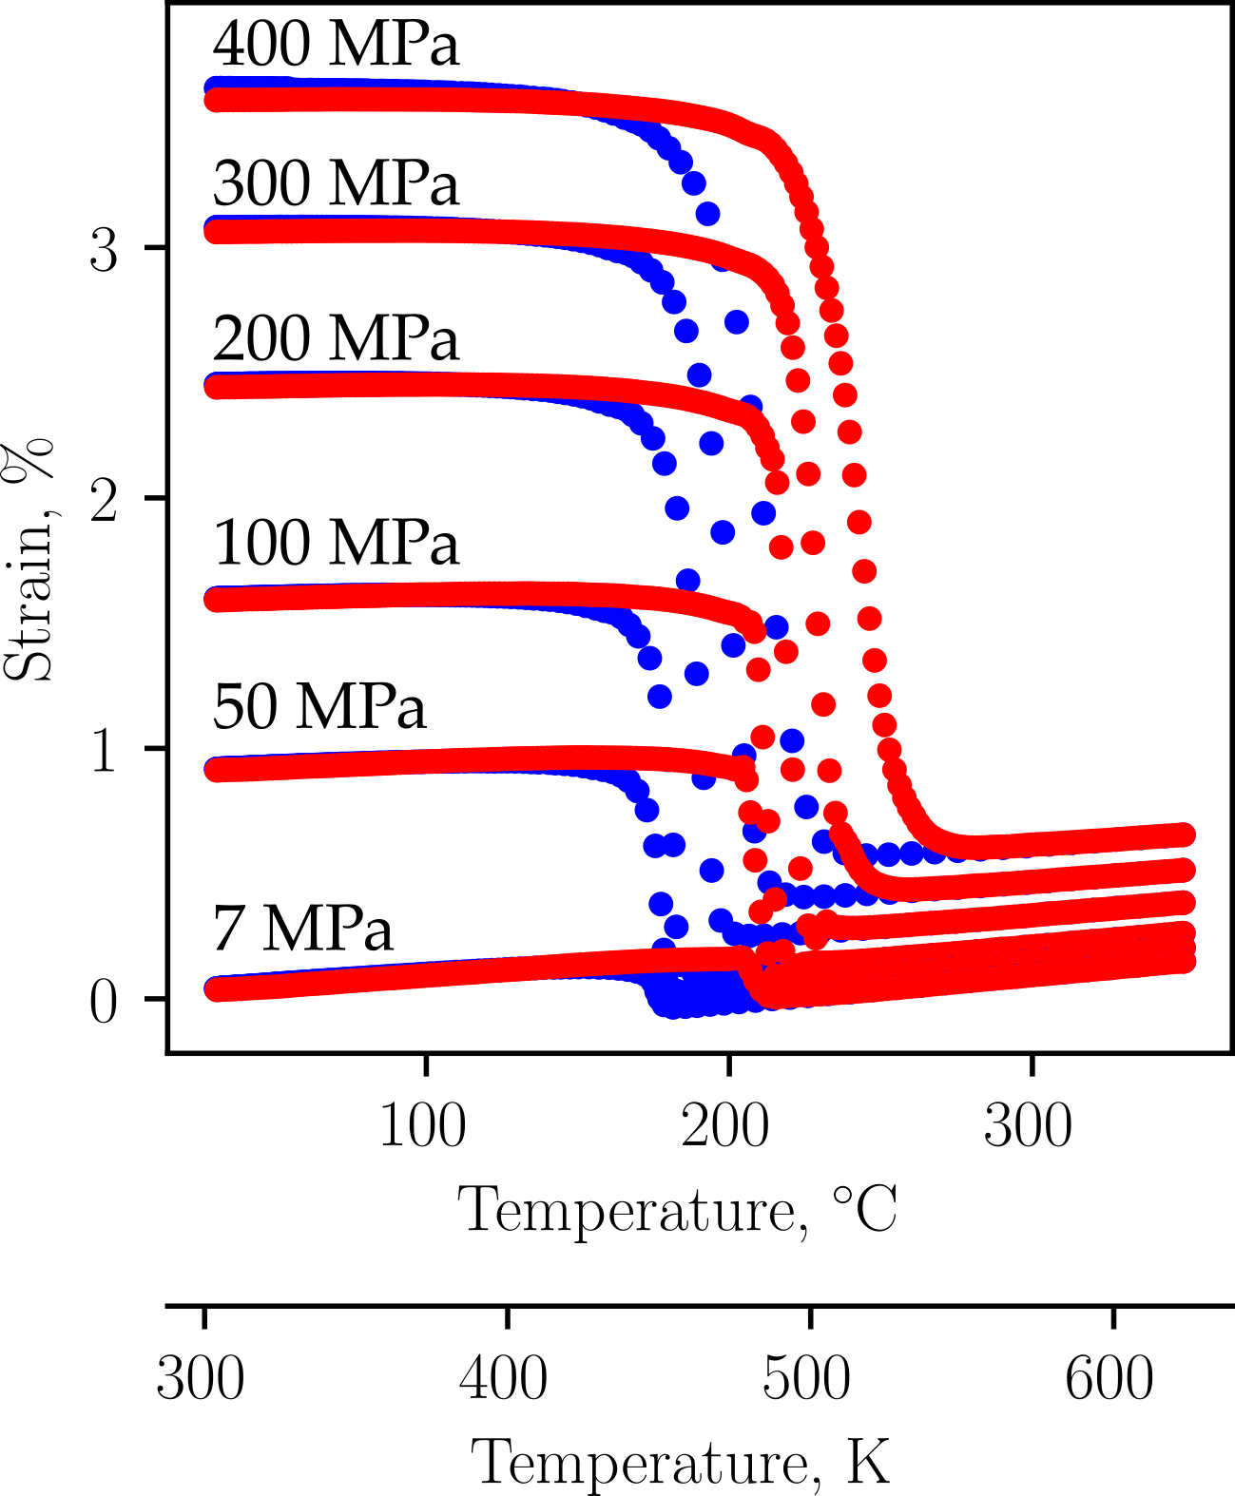

Figure : To demonstrate the utility of SMA-REACT, we will calibrate a constitutive model to fit the above published experimental data [31].

## Identifying material property bounds

To produce an accurate calibration using SMA-REACT, material parameter bounds must be estimated. We discuss how to derive estimates for transformation temperatures, stress-influence coefficients, and austenite elastic modulus from constant force thermal cycling (CFTC) data, as incorrect bounds for these parameters may produce non-physical results (i.e., if is higher than ). These essential material parameter estimates are depicted graphically in Figure 4.

Transformation temperatures are the most important property to correctly estimate. For each tested stress level, they can be estimated via the tangent method or similar. Zero-stress transformation temperatures can then be found via the x-intercept of a linear regression of the transformation temperatures as a function of stress. This estimate is equivalent to a Lagoudas model calibration with smooth hardening parameters set to . Bounds for each transformation temperature are typically 10-20 K around each parameter (e.g., for an estimated of 150 K, the lower and upper bounds would be 130 K and 170 K, respectively).

The average slope of the martensite and austenite transformation surfaces for martensite and austenite for a specified stress range about the user-determined *calibration stress*  can be taken as the stress-influence coefficients ( and ). Note that the stress-influence coefficients should not be derived from the average slope from estimated transformation temperatures at all stress levels, as most shape memory alloys exhibit a nonlinear change in transformation temperature with respect to stress (see Figure 3(b) in [31] and Lagoudas et al [5] for more information). The stress-influence coefficient bounds are then set to vary by 1 MPa/K in each direction.

Austenite elastic modulus can be estimated by extracting the total strains at a temperature well above at each tested stress level. Then, by designating this temperature , Hooke’s law becomes:

Where denotes the martensite volume fraction and represents the transformation strain. Austenite elastic modulus is the best-fit linear coefficient from this equation.

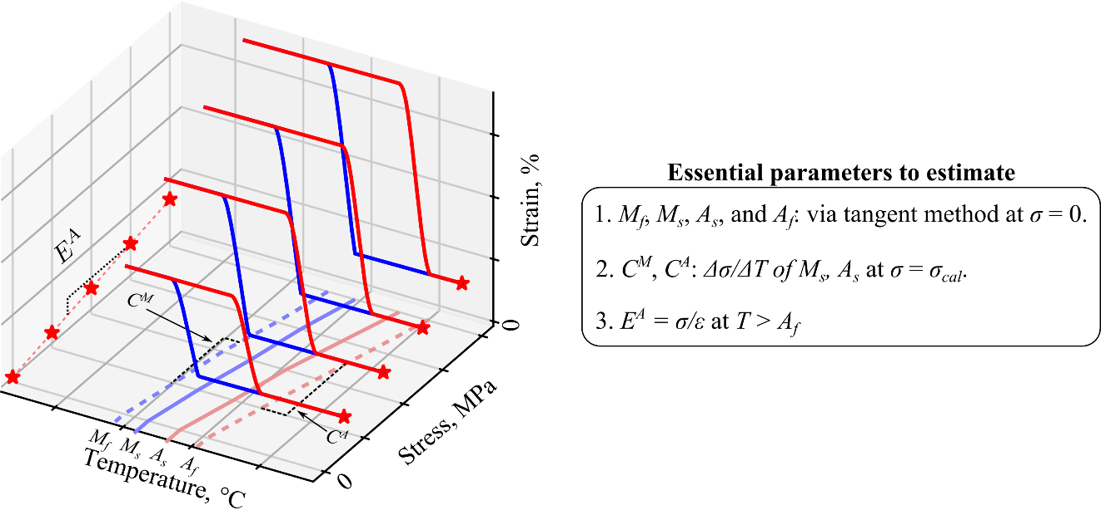

Figure 4: Given constant-stress thermal cycling (CFTC) data for several stress levels, transformation temperatures, stress-influence coefficients, and the austenite elastic modulus can be estimated via simple relations. These estimates provide optimization bounds for numerical calibration of the entire seventeen-parameter Lagoudas constitutive model.

Estimating the remaining material property bounds (Martensite elastic modulus, transformation strain properties, thermal expansion coefficient, and smooth hardening coefficients) requires a nonlinear curve fitting routine. In practice, estimating the aforementioned properties and applying best practices for the remaining properties results in a sufficient preliminary calibration.

Table 2 shows typical bounds for a preliminary calibration. As mentioned previously, austenite elastic modulus, transformation temperatures, and stress-influence coefficients can be estimated via linear regression. Martensite elastic modulus is commonly lower than the austenite elastic modulus, so common practice entails setting a lower bound equal to one-half the estimated austenite value. The coefficient of thermal expansion is commonly bounded to a maximum of for preliminary calibrations.

Transformation strain properties are the most difficult property group to accurately estimate during a preliminary calibration. This is due to the exponential nature of the transformation strain function (see Equation 1 or Reference [5]) and the large sensitivity of transformation strain properties on overall calibration error. The minimum transformation strain or critical stress at which transformation strain manifests , or both, are commonly set to zero for preliminary calibrations.

Smooth hardening coefficients are typically the last parameters to be refined. As we do in the next section, these parameters are commonly set to one for preliminary calibrations to reduce the number of active design variables. When thermoelastic properties and transformation strain properties have converged, the smooth hardening coefficients and transformation temperatures are refined.

Table : Common starting bounds for each Lagoudas constitutive material parameter. Note that these are guidelines and should be modified after a preliminary calibration.

|  |  |  |
| --- | --- | --- |
| **Parameter** | **Mathematical symbol** | **Bounds (SI)** |
| **Thermoelastic properties** |  |  |
| Austenite elastic modulus |  | Eq. 2, Figure 5 |
| Martensite elastic modulus |  |  |
| Thermal expansion coefficient |  | mm/mm |
| **Transformation properties** |  |  |
| Transformation temperatures (at zero-stress) |  | Figure 5 |
| Stress-influence coefficients |  | Figure 5 |
| **Transformation strain properties** |  |  |
| Minimum transformation strain |  | [0, 0.01][2] mm/mm |
| Maximum transformation strain |  | [0.01, 0.05] mm/mm |
| Critical stress at which transformation strain manifests |  | [0, 50E6]4 Pa |
| Transformation strain rise time |  | [1E-8, 1E-6] 1/Pa |
| **Smooth hardening properties** |  |  |
| Smooth hardening coefficients |  | [0, 1][3] |

## Iterative calibration with SMA-REACT

The best practices detailed in the previous section inform optimization bounds for a preliminary calibration. Then, we use SMA-REACT to update select parameter bounds and further improve the calibration result. For this example, we set the critical stress at which transformation strain manifests and the minimum transformation strain to zero, as the material of interest exhibits low transformation strain at low applied stress levels.

Table 3 shows the final error achieved by each calibration and details the bounds and specified values. The process of iteratively updating bounds is further contextualized in Figure 5, where the evolution of select material parameters are plotted with respect to the calibration. The preliminary calibration obtained a mean squared error between model prediction and experimental data of 1.51%. While this calibration may be sufficient for certain applications, many parameters converged to the bounds (see , , and in Figure 5). By modifying these bounds, the subsequent calibration decreased mean squared error to 1.34% and all parameters converged to an intermediate value. Finally, to match the smooth hardening behavior during transformation, a final calibration was performed. In this calibration, all material parameters besides the transformation temperatures and smooth hardening coefficients were set to the previous optimized value. This final calibration decreased the error between model prediction and experimental data to 1.30%.

Table : Estimating bounds enables a calibration within 2% error. Parameter tuning via SMA-REACT further improves the calibration to 1.30% error.

|  |  |  |
| --- | --- | --- |
| **Calibration** | **Error** | **Notes** |
| 1 | 1.51% | Estimated bounds (see previous section). . . |
| 2 | 1.34% | Modified bounds based on converged values. . . |
| 3 | 1.30% | Specified all properties besides transformation temperatures and smooth hardening coefficients. |

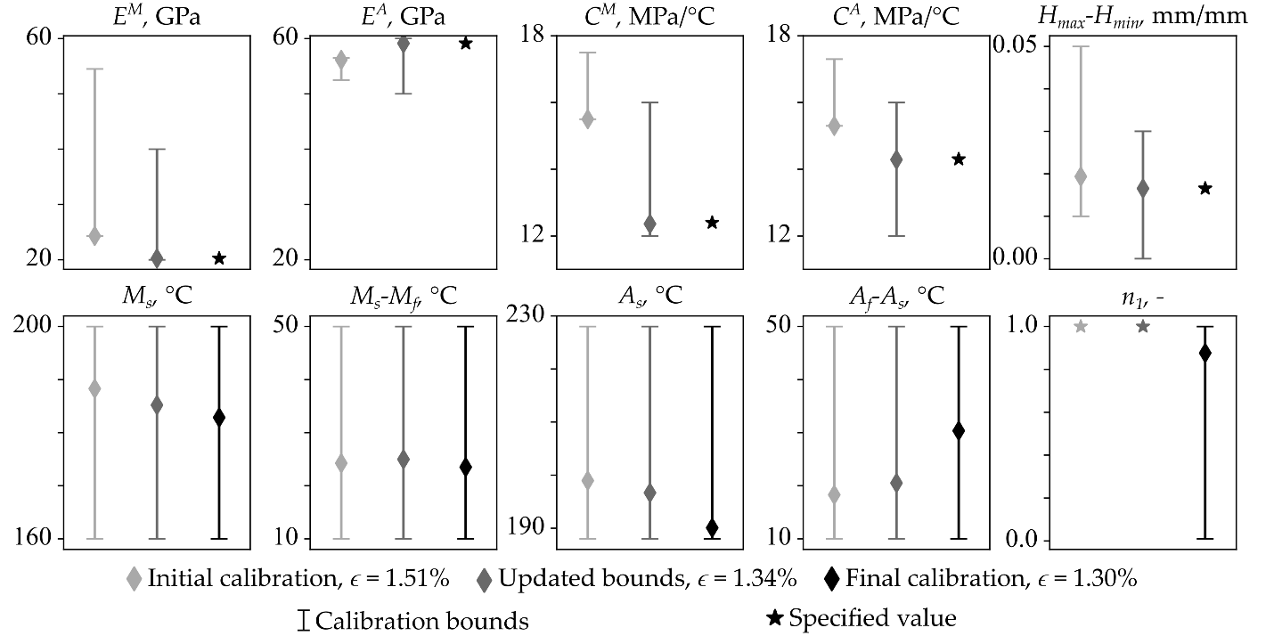

Figure 5: Evolution of selected material parameters for the calibration example; the entire parameter histories are provided in the appendix. Initial bounds identified from experimental data and best practices (see Table 2) were then refined if the value converged to a bound (e.g., ). All properties besides transformation temperatures and smooth hardening coefficients were set for the final calibration.

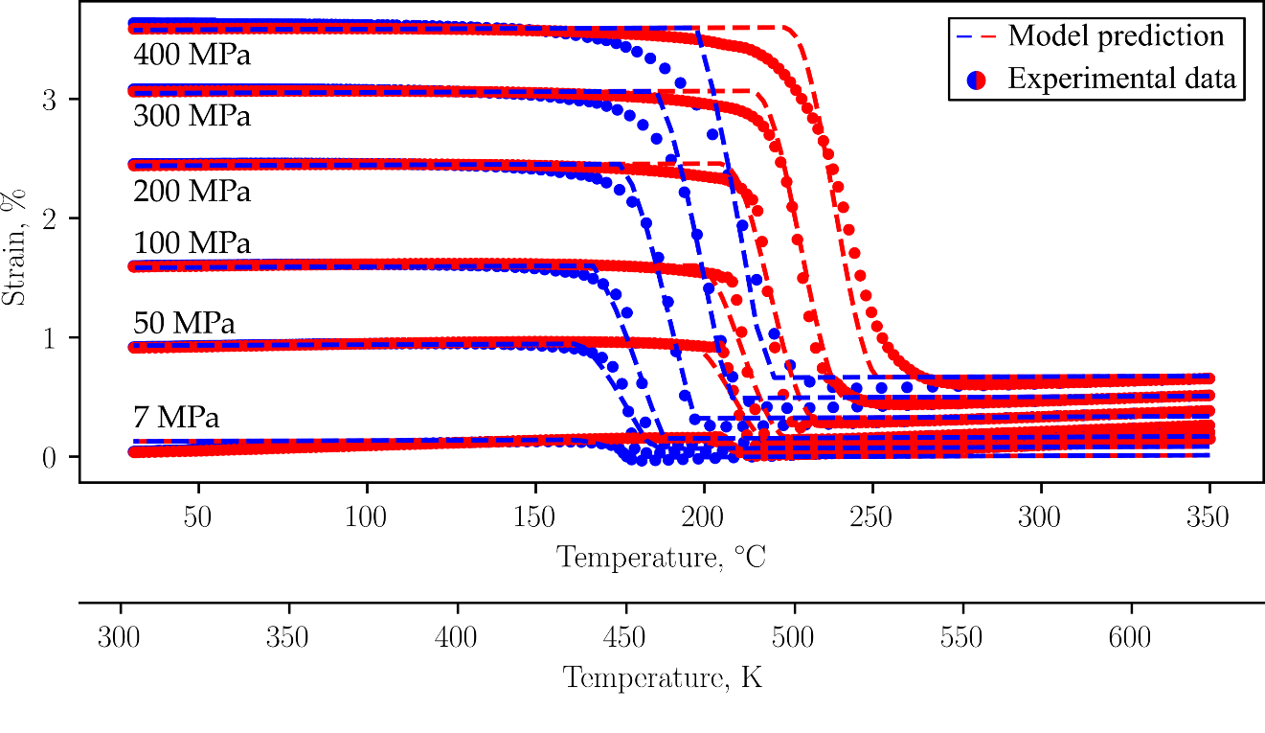

Figure 6: The final calibration agrees with the experimental data to within 1.30% mean squared error.

The final calibration is depicted in Figure 6. The model predicts the elastic response in martensite accurately, which signifies that both the martensitic elastic modulus and transformation strain properties are well calibrated. This calibration exemplifies the utility of numerical optimization; the optimizer finds the best global fit, especially regarding the austenite transformation temperatures. For lower stresses, is too low and is too high. Then, at 300 MPa, is too high and is too low. While the calibration could be improved by biasing the solution to prioritize fitting certain stress levels (see [26]) or by calibrating the model at the stress levels that matter most, most discrepancies arise from limitations in the model formulation and not the calibration routine.

The iterative calibration process via SMA-REACT provides an accurate constitutive model and can even be accomplished in less than an hour on a lightweight laptop with a low-performance processor (Intel Core m3-6Y30 CPU @ 0.90 GHz with 4 Gb RAM). This calibration routine can be performed by general analysts, designers, or material scientists, without the need for exotic hardware or extensive programming experience.

# Conclusions and further refinements

SMA-REACT is an open-source, user-friendly tool for post-processing and constitutive model calibration for shape memory alloy experimental data. By framing the calibration routine as a numerical optimization problem, SMA-REACT can find robust solutions within 1.3% mean squared error between model predictions and experimental data. SMA-REACT does not require detailed knowledge of programming, optimization, or the Lagoudas constitutive model. This allows the tool to be approachable for students and professionals working on shape memory alloys. By allowing the user to fine-tune calibrations, SMA-REACT eliminates a potential bottleneck between experimental characterization and system finite element modeling.

We distribute the SMA-REACT toolset and source code under the GNU General Public License, which allows anyone to run, study, share, and modify the code. We invite any enhancements to the current codebase, including, but not limited to, alternative loading modes (e.g., superelasticity or combined superelasticity/shape memory [32]), alternative constitutive models [6], [33], [34], [35], or any usability enhancements for more robust data import or export. In particular, we believe integration with other open-source tools, such as the Shape Memory Materials Database and SMAnalytics would be very enabling to the greater SMA community [13]. SMA-REACT aims to reduce the barrier between materials scientists and engineers, and will hopefully enable more widespread adoption of shape memory alloys in engineering applications.

# Bibliography

[1] D. C. Lagoudas, *Shape Memory Alloys: Modeling and Engineering Applications*. Springer, 2008.

[2] J. M. Jani, M. Leary, A. Subic, and M. A. Gibson, “A review of shape memory alloy research, applications and opportunities,” *Mater. Des.*, vol. 56, pp. 1078–1113, 2014, doi: 10.1016/j.matdes.2013.11.084.

[3] B. T. Lester, T. Baxevanis, Y. Chemisky, and D. C. Lagoudas, “Review and perspectives: shape memory alloy composite systems,” *Acta Mech.*, vol. 226, no. 12, pp. 3907–3960, Dec. 2015, doi: 10.1007/s00707-015-1433-0.

[4] M. Elahinia, M. Nematollahi, K. S. Baghbaderani, A. Nespoli, and F. Stortiero, “Chapter 6 - Manufacturing of shape memory alloys,” in *Shape Memory Alloy Engineering (Second Edition)*, A. Concilio, V. Antonucci, F. Auricchio, L. Lecce, and E. Sacco, Eds., Boston: Butterworth-Heinemann, 2021, pp. 165–193. doi: 10.1016/B978-0-12-819264-1.00006-6.

[5] D. Lagoudas, D. Hartl, Y. Chemisky, L. Machado, and P. Popov, “Constitutive Model for the Numerical Analysis of Phase Transformation in Polycrystalline Shape Memory Alloys,” *Int. J. Plast.*, vol. 32–33, pp. 155–183, 2012.

[6] L. C. Brinson, “One-Dimensional Constitutive Behavior of Shape Memory Alloys: Thermomechanical Derivation with Non-Constant Material Functions and Redefined Martensite Internal Variable,” *J. Intell. Mater. Syst. Struct.*, vol. 4, pp. 229–242, 1993.

[7] W. Trehern, R. Ortiz-Ayala, K. C. Atli, R. Arroyave, and I. Karaman, “Data-driven shape memory alloy discovery using Artificial Intelligence Materials Selection (AIMS) framework,” *Acta Mater.*, vol. 228, p. 117751, Apr. 2022, doi: 10.1016/j.actamat.2022.117751.

[8] A. Demblon, J. H. Mabe, and I. Karaman, “Compositional effects on strain-controlled actuation fatigue of NiTiHf high temperature shape memory alloys,” *Scr. Mater.*, vol. 242, p. 115904, Mar. 2024, doi: 10.1016/j.scriptamat.2023.115904.

[9] S. J. Honrao, O. Benafan, and J. W. Lawson, “Data-Driven Study of Shape Memory Behavior of Multi-Component Ni–Ti Alloys in Large Compositional and Processing Space,” *Shape Mem. Superelasticity*, vol. 9, no. 1, pp. 144–155, Mar. 2023, doi: 10.1007/s40830-022-00405-x.

[10] M. C. Kuner, A. A. Karakalas, and D. C. Lagoudas, “ASMADA—A tool for automatic analysis of shape memory alloy thermal cycling data under constant stress,” *Smart Mater. Struct.*, vol. 30, no. 12, p. 125003, 2021.

[11] ASTM, “Standard test method for mechanical uniaxial constant force thermal cycling of shape memory alloys,” ASTM International, West Conshohocken, PA, E3097-17, 2017. [Online]. Available: https://www.astm.org/e3097-17.html

[12] D. E. Nicholson *et al.*, “Standardization of Shape Memory Alloys from Material to Actuator,” *Shape Mem. Superelasticity*, vol. 9, no. 2, pp. 353–363, Jun. 2023, doi: 10.1007/s40830-023-00431-3.

[13] O. Benafan, G. S. Bigelow, and A. W. Young, “Shape Memory Materials Database Tool—A Compendium of Functional Data for Shape Memory Materials,” *Adv. Eng. Mater.*, vol. 22, no. 7, p. 1901370, 2020, doi: 10.1002/adem.201901370.

[14] P. E. Caltagirone and O. Benafan, “Shape Memory Materials Analysis and Research Tool (SM2ART): Finding Data Anomalies and Trends,” *Shape Mem. Superelasticity*, Jul. 2023, doi: 10.1007/s40830-023-00457-7.

[15] D. Hartl and D. C. Lagoudas, “Characterization and 3–D Modeling of Ni60Ti SMA for Actuation of a Variable Geometry Jet Engine Chevron,” in *Proceedings of SPIE, Smart Structures and Materials*, San Diego, CA, Mar. 2007, pp. 1–12.

[16] L. Xu, T. Baxevanis, and D. C. Lagoudas, “A three-dimensional constitutive model for the martensitic transformation in polycrystalline shape memory alloys under large deformation,” *Smart Mater. Struct.*, vol. 28, no. 7, p. 074004, Jun. 2019, doi: 10.1088/1361-665X/ab1acb.

[17] L. Xu, A. Solomou, T. Baxevanis, and D. Lagoudas, “Finite strain constitutive modeling for shape memory alloys considering transformation-induced plasticity and two-way shape memory effect,” *Int. J. Solids Struct.*, vol. 221, pp. 42–59, Jun. 2021, doi: 10.1016/j.ijsolstr.2020.03.009.

[18] G. Scalet, F. Niccoli, C. Garion, P. Chiggiato, C. Maletta, and F. Auricchio, “A three-dimensional phenomenological model for shape memory alloys including two-way shape memory effect and plasticity,” *Mech. Mater.*, vol. 136, p. 103085, Sep. 2019, doi: 10.1016/j.mechmat.2019.103085.

[19] F. Auricchio, A. Coda, A. Reali, and M. Urbano, “SMA Numerical Modeling Versus Experimental Results: Parameter Identification and Model Prediction Capabilities,” *J. Mater. Eng. Perform.*, vol. 18, no. 5, pp. 649–654, Aug. 2009, doi: 10.1007/s11665-009-9409-7.

[20] D. J. Hartl and D. C. Lagoudas, “Thermomechanical Characterization of Shape Memory Alloy Materials,” in *Shape Memory Alloys: Modeling and Engineering Applications*, D. C. Lagoudas, Ed., New York: Springer-Verlag, 2008.

[21] D. Whitten and D. Hartl, “Iterative calibration of a shape memory alloy constitutive model from 1D and 2D data using optimization methods,” in *Behavior and Mechanics of Multifunctional Materials and Composites 2014*, SPIE, 2014, pp. 21–31.

[22] *Material Calibration - 3DExperience*. (Oct. 08, 2024). Dassault Systemes, Woodlands Hills, CA. Accessed: Oct. 08, 2024. [Online]. Available: https://help.3ds.com/2024x/English/DSDoc/MatCalibUserMap/matcalib-c-ov.htm?contextscope=cloud&id=27e963e7360f4cddb5af8a8c7ab38e45&_gl=1*rhnu28*_up*MQ..*_ga*MTI1NDEzMTAyLjE3MjgzOTc0NTE.*_ga_DYJDKXYEZ4*MTcyODM5NzQ1MS4xLjAuMTcyODM5NzQ1MS4wLjAuMA..*_ga_39DKQ0LYW1*MTcyODM5NzQ1MS4xLjEuMTcyODM5NzQ1MS4wLjAuMA..

[23] Free Software Foundation, “The GNU General Public License v3.0 - GNU Project - Free Software Foundation.” Accessed: Nov. 08, 2024. [Online]. Available: https://www.gnu.org/licenses/gpl-3.0.en.html

[24] P. B. C. Leal and M. A. Savi, “Shape memory alloy-based mechanism for aeronautical application: Theory, optimization and experiment,” *Aerosp. Sci. Technol.*, vol. 76, pp. 155–163, May 2018, doi: 10.1016/j.ast.2018.02.010.

[25] P. Walgren *et al.*, “Development and Testing of a Shape Memory Alloy-Driven Composite Morphing Radiator,” *Shape Mem. Superelasticity*, pp. 1–10, Jan. 2018, doi: 10.1007/s40830-018-0147-2.

[26] P. Walgren, S. Nevin, and D. Hartl, “Design, experimental demonstration, and validation of a composite morphing space radiator,” *J. Compos. Mater.*, p. 00219983221144499, Dec. 2022, doi: 10.1177/00219983221144499.

[27] K. Deb, A. Pratap, S. Agarwal, and T. Meyarivan, “A fast and elitist multiobjective genetic algorithm: NSGA-II,” *IEEE Trans. Evol. Comput.*, vol. 6, no. 2, pp. 182–197, 2002.

[28] F.-A. Fortin, F.-M. D. Rainville, M.-A. Gardner, M. Parizeau, and C. Gagné, “DEAP: Evolutionary Algorithms Made Easy,” *J. Mach. Learn. Res.*, vol. 13, pp. 2171–2175, Jul. 2012.

[29] P. Virtanen *et al.*, “SciPy 1.0: fundamental algorithms for scientific computing in Python,” *Nat. Methods*, vol. 17, no. 3, pp. 261–272, Mar. 2020, doi: 10.1038/s41592-019-0686-2.

[30] J. C. Simo and T. J. R. Hughes, “Integration Algorithms for Plasticity and Viscoplasticity,” in *Computational Inelasticity*, in Interdisciplinary Applied Mathematics. , New York, NY: Springer, 1998, pp. 113–153. doi: 10.1007/0-387-22763-6_3.

[31] G. S. Bigelow, A. Garg, O. Benafan, R. D. Noebe, S. A. Padula, and D. J. Gaydosh, “Development and testing of a Ni50.5Ti27.2Hf22.3 high temperature shape memory alloy,” *Materialia*, vol. 21, p. 101297, Mar. 2022, doi: 10.1016/j.mtla.2021.101297.

[32] P. B. C. Leal, M. Cabral-Seanez, V. B. Baliga, D. L. Altshuler, and D. J. Hartl, “Phase transformation-driven artificial muscle mimics the multifunctionality of avian wing muscle,” *J. R. Soc. Interface*, vol. 18, no. 184, p. 20201042, Nov. 2021, doi: 10.1098/rsif.2020.1042.

[33] L. C. Brinson and M. S. Huang, “Simplifications and Comparisons of Shape Memory Alloy Constitutive Models,” *J. Intell. Mater. Syst. Struct.*, vol. 7, pp. 108–114, 1996.

[34] F. Auricchio, R. L. Taylor, and J. Lubliner, “Shape-Memory Alloys: Macromodelling and Numerical Simulations of the Superelastic Behavior,” *Comput. Methods Appl. Mech. Eng.*, vol. 146, pp. 281–312, 1997.

[35] F. Auricchio and E. Sacco, “A One-Dimensional Model for Superleastic Shape-Memory Alloys With Different Elastic Properties Between Austenite and Martensite,” *Int. J. Non-Linear Mech.*, vol. 32, no. 6, pp. 1101–1114, 1997.

# Appendix: Full calibration parameter history

*Table 4: Calibration parameter history for the example discussed in the text. Values displayed with a red background converged to a bound, while those with a blue background were specified and not optimized.*

|  |  |  |  |
| --- | --- | --- | --- |
|  | **Calibration** | | |
| **Property** | **1** | **2** | **3** |
| (GPa) | 24.3 | 20.2 | 20.2 |
| (GPa) | 56.1 | 59.1 | 59.1 |
| (1/) | 1.00E-6 | 1.07E-6 | 1.07 |
| () | 188 | 185 | 183 |
| () | 24.2 | 25.0 | 23.5 |
| () | 199 | 197 | 190 |
| () | 18.3 | 20.5 | 30.4 |
| (MPa/) | 15.5 | 12.4 | 12.4 |
| (MPa/) | 15.3 | 14.3 | 14.3 |
| (mm/mm) | 0 | 0 | 0 |
| (mm/mm) | 1.94E-2 | 1.65E-2 | 1.65E-2 |
| (mm/mm) | 0 | 0 | 0 |
| (1/MPa) | 1.00E-2 | 1.14E-2 | 1.14E-2 |
| (-) | 1 | 1 | 0.877 |
| (-) | 1 | 1 | 0.412 |
| (-) | 1 | 1 | 0.505 |
| (-) | 1 | 1 | 0.288 |

Table 4 shows the full material parameter history; a subset of these parameters are depicted graphically in Figure 5. In this table, parameters displayed with a blue background were specified for the optimization, while those with a red background converged to an optimization bound. The final optimized solution displayed in Figure 6 corresponds to the material parameters of calibration three. This table demonstrates the importance of iterative calibration after estimating key parameters; both stress-influence coefficients ( and ) required much lower bounds than originally estimated.

1. The calibration stress is *a priori* defined by the designer. Common practice dictates selecting a value close to the material design working stress.
2. The minimum transformation strain and critical stress at which transformation strain are commonly set to zero for preliminary calibrations and only optimized if modeling two-way shape memory behavior is essential.
3. We recommend setting smooth hardening coefficients to one for preliminary calibrations.